**Problems on Unconstrained Optimization**

**Due date: 11 Bhadra, 2081**

*In problems 1 – 13, locate all relative maxima, relative minima, and saddle points, if any*.

**1.** *f* (*x, y*)= *y*2 + *xy* + 3*y* + 2*x* + 3 **Ans.** saddle point at (1*,*−2)

**2.** *f* (*x, y*)= *x*2 + *xy* − 2*y* − 2*x* + 1 **Ans.** at (2, –2), saddle point

**3.** *f* (*x, y*)= *x*2 + *xy* + *y*2 − 3*x* **Ans.** relative minimum at (2*,*−1)

**4.** *f* (*x, y*)= *xy* − *x*3 − *y*2 **Ans.** saddle point at (0,0), relative maximum at (1/6; 1/12)

**5.** *f* (*x, y*)= *x*2 + *y*2 + 2*xy* **Ans.** relative minima at (−1*,*−1*)* and (1*,* 1)

**6.** *f* (*x, y*)= 2*x*2 − 4*xy* + *y*4 + 2 **Ans.** saddle point at (0*,* 0); relative minima at (1*,* 1)and (−1*,*−1)

**7.** *f* (*x, y*)= *xey*  **Ans.** no critical points

**8.** *f* (*x, y*)= *x*2 + *y* − *ey* **Ans.** saddle point at (0*,* 0)

**9.** *f* (*x, y*)= *xy* + + **Ans.** relative minimum at (1; 2)

**10.** *f* (*x, y*)= *ex* sin *y* **Ans.** no critical points

**11.** *f* (*x, y*)= *y* sin *x* **Ans.** saddle points at (nπ, 0)

**12.** *f* (*x, y*)= *e*−(*x*2+*y*2+2*x*) **Ans.** relative maximum at (−1*,* 0)

**13.** *f* (*x, y*)= *xy* + + (*a* ≠ 0*, b* ≠ 0) **Ans.** relative maximum at (a2/b, b2/a)

**14.** A company manufactures running shoes and basketball shoes. The total revenue from *x*1 units of running shoes and *x*2 units of basketball shoes is

*R* = –5*x*12 – 8*x*22 – 2*x*1*x*2 + 42*x*1 + 102*x*2

where *x*1 and *x*2 are in thousands of units. Find *x*1 and *x*2 so as to maximize the revenue.

**Ans.** Revenue is maximized when *x*1 = 3 and *x*2 = 6.

**15.** A corporation manufactures candles at two locations. The cost of producing *x*1 units at location 1 is

*C*1 = 0.02 *x*12 + 4 *x*1 + 500

and the cost of producing units at location 2 is

*C*2 = 0.05 *x*22 + 4 *x*2 + 275.

The candles sell for $15 per unit. Find the quantity that should be produced at each location to maximize the profit

*P* = 15(*x*1 + *x*2) – *C*1 – *C*2.

**Ans.** Profit is maximized when *x*1 = 275 and *x*2 = 110.

16. A company manufactures two items which are sold in two separate markets where it has a monopoly. The quantities, *q*1 and *q*2, demanded by consumers, and the prices, *p*1 and *p*2 (in dollars), of each item are related by

*p*1 = 600 − 0.3*q*1 and *p*2 = 500 − 0.2*q*2.

Thus, if the price for either item increases, the demand for it decreases. The company’s total production cost is given by

*C* = 16+1.2*q*1 + 1.5*q*2 + 0.2*q*1*q*2.

To maximize its total profit, how much of each product should be produced? What is the maximum profit?

**Ans.** The maximum profit *P*(699.1, 896.7) ≈ $433,000.

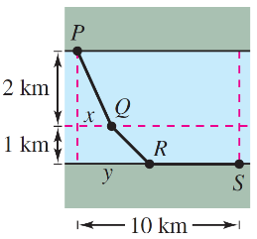**17.** A water line is to be built from point *P* to *S* point and must pass through regions where construction costs differ (see figure). The cost per kilometer (in dollars) is 3*k* from *P* to *Q*, 2*k* from *Q* to *R* and *k* from *R* to *S*. Find *x* and *y* such that the total cost *C* will be minimized.

**Ans.** *x* = ≈ 0.707km and *y* = ≈ 1284 km.

**18.** Let *f* (*x, y*) = 3*x*2 +*ky*2 +9*xy*. Determine the values of *k* (if any) for which the critical point at (0*,* 0) is:

**(a)** A saddle point

**(b)** A local maximum

**(c)** A local minimum

**19.** Let *f* (*x, y*) = *x*3 + *ky*2 − 5*xy*. Determine the values of *k* (if any) for which the critical point at (0*,* 0) is:

**(a)** A saddle point

**(b)** A local maximum

**(c)** A local minimum

**Ans.** (a) All values of *k* (b) None (c) None

**20.** Find a least squares line for the following data points: (1*,* 1), (2*,* 1), and (3*,* 3).

Hint:

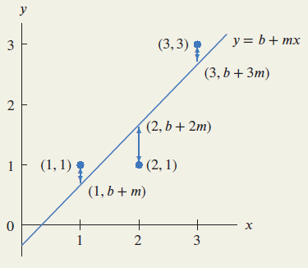

The least squares line minimizes *f* (*b, m*), the sum of the squares of these vertical distances.

**Ans.** *b* = −1∕3 and *m* = 1

**21.** Find the point on the plane *z* = *x* + *y* + 1 closest to the point *P* = (1*,* 0*,* 0).

**V Ans.** The closest point on the plane to P=(1,0,0) is (−1/3,−1/3,1/3).